Use-Case Realization Report
Generate Question

Issue <1.0>
Revision History
Date | Issue | Description | Author
<dd/mmm/yy> | <x.x> | <details> | <name>

Table of Contents
1. Brief Description 4
2. Flow of Events 4
2.1 Standard Flow 4
3. Interaction Diagrams 4
3.1 Collaboration Diagram for Generate Question 4
4. Participating Objects 4
5. Class Diagrams 6
5.1 Class Diagram for Generate Question 6
6. Derived Requirements 6

Use-Case Realization Report
Generate Question

Brief Description

Flow of Events

Standard Flow
- Exam Controller gets input from user, and retrieves the specific exam from the database.
- System needs to get every exam sections for exam to be generated.
- According to the configurations of exam and exam section, e.g. how many easy, medium and hard questions, Exam Controller will randomly pick up relevant questions and question options.

Interaction Diagrams

Collaboration Diagram for Generate Question
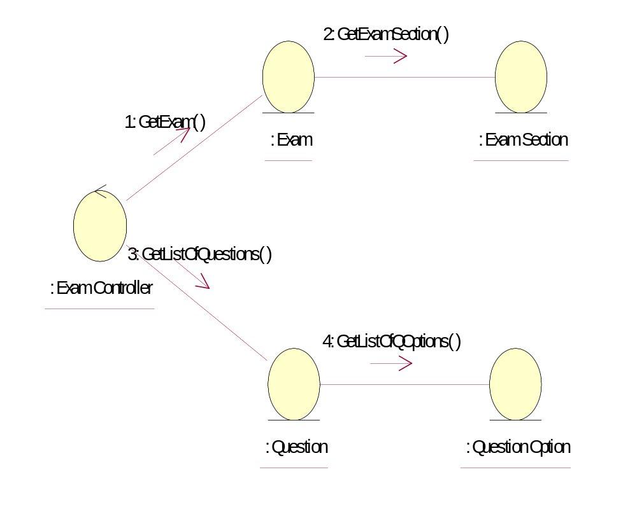

Participating Objects
: Exam
This entity stores exams, like moduleID, ExamID, ExamName etc.
: Exam Controller
This cotroller will in charge of creating exam questions, monitoring exam progress, like the user answers, and the time spent, navigating questions etc. It will also save the result into Exam Result table and Exam Result Detail table.
: Exam Section
Exam Section contains the sections for every exam.
: Question
This entity stores the details of the question.
: Question Option
This entity contains the options of the questions, as well as mark what options are correct answers

Class Diagrams

Class Diagram for Generate Question
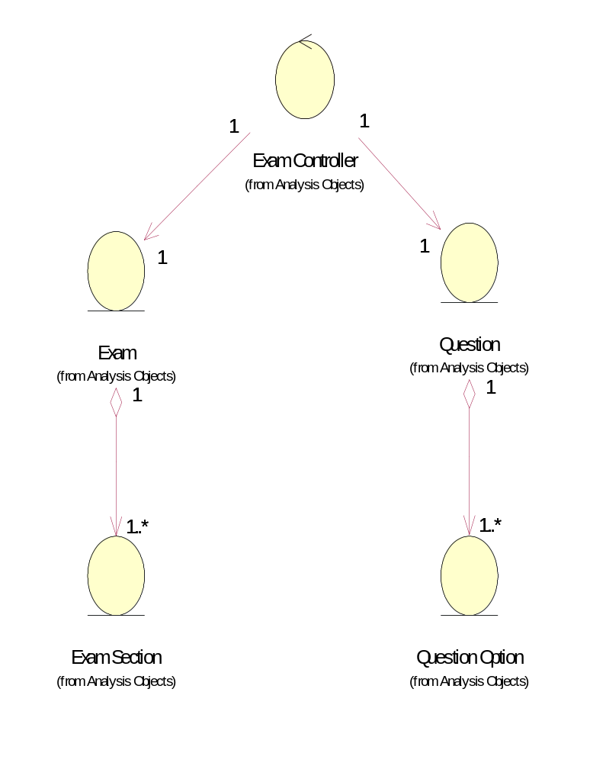

Derived Requirements
No derived requirements.

